**DECISION TABLE**

**PROJECT : HOSTEL ALLOCATION SYSTEM**

**TEAM MEMBERS : Sahil Singla (18103017) , Manav Singla (18103065)**

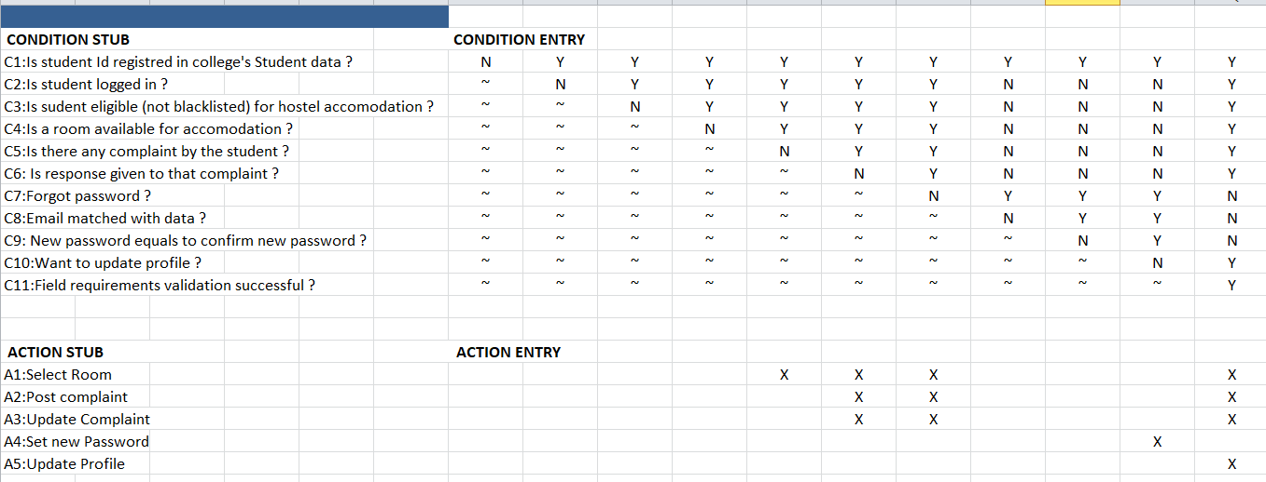**Students Decision Table**

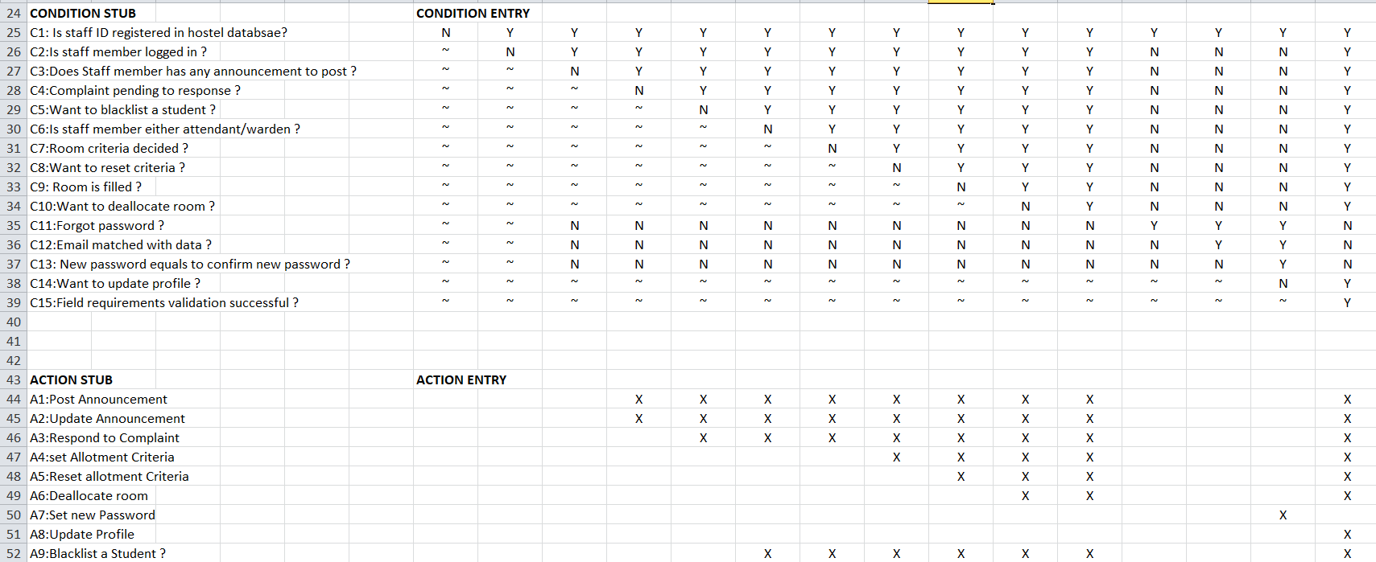**Staff Decision Table**